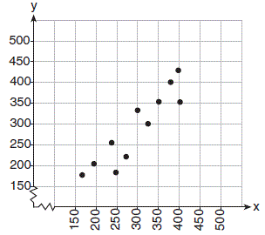
Unit 12 Practice Test:
- What is the correlation coefficient of the linear fit of the data shown below, to the nearest hundredth?

- 1.00
- 0.93
- -0.93
- -1.00
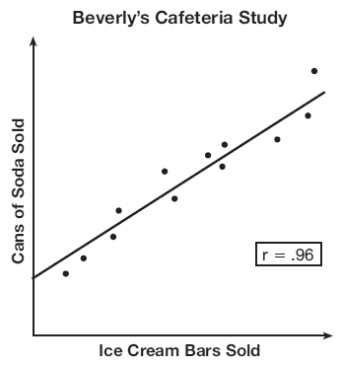
- Beverly did a study this past spring using data she collected from a cafeteria. She recorded data weekly for ice cream sales and soda sales. Beverly found the line of best fit and the correlation coefficient, as shown in the diagram below. Given this information, which statement(s) can correctly be concluded?
I. Eating more ice cream causes a person to become thirsty.
II. Drinking more soda causes a person to become hungry.
III. There is a strong correlation between ice cream sales and soda sales.
- I, only
- III, only
- I and III
- II and III
- The data obtained from a random sample of track athletes showed that as the foot size of the athlete decreased, the average running speed decreased. Which statement is best supported by the data?

- Smaller foot sizes cause track athletes to run slower.
- The sample of track athletes shows a causal relationship between foot size and running speed.
- The sample of track athletes shows a correlation between foot size and running speed.
- There is no correlation between foot size and running speed in track athletes.
- Analysis of data from a statistical study shows a linear relationship in the data with a correlation coefficient of −0.524. Which statement best summarizes this result?

- There is a strong positive correlation between the variables.
- There is a strong negative correlation between the variables.
- There is a moderate positive correlation between the variables.
- There is a moderate negative correlation between the variables.

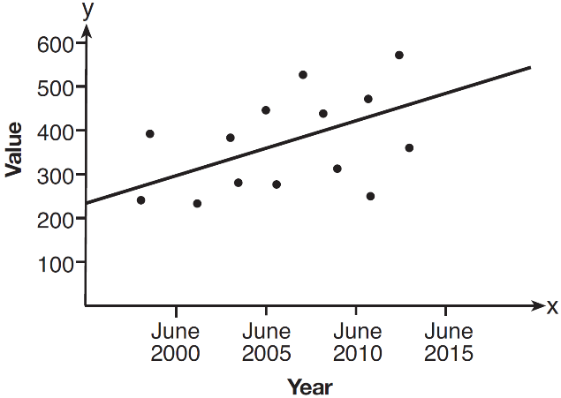
- Based on the line of best fit drawn below, which value could be expected for the data in June 2015?

- 230 3. 310
- 480 4. 540

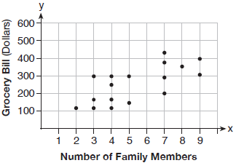
- The scatter plot below shows the relationship between the number of members in a family and the amount of the family's weekly grocery bill. The most appropriate prediction of the grocery bill for a family that consists of six members is
- $100
- $300
- $400
- $500
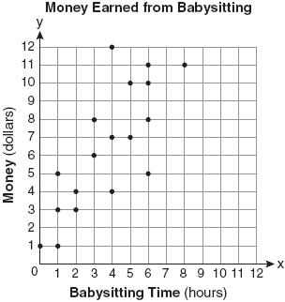
- Which equation most closely represents the line of best fit for the scatter plot below?

- 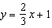
- 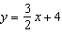
- 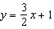

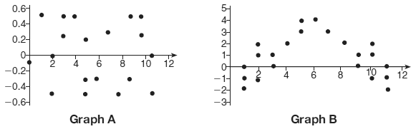
- The residual plots from two different sets of bivariate data are graphed below.
Explain, using evidence from graph A and graph B, which graph indicates that the model for the data is a good fit.

- A radio station did a survey to determine what kind of music to play by taking a sample of middle school, high school, and college students. They were asked which of three different types of music they prefer on the radio: hip-hop, alternative, or classic rock. The results are 22 out of 50 high school students prefer Hip-Hop and 6 prefer classic rock. 18 out of 50 middle school students prefer Alternative music while 4 prefer classic rock. There are also 24 students who prefer classic rock, 66 students prefer Hip-Hop, and 50 College students.
 | Hip-Hop | Alternative | Classic Rock | Total
Middle School
High School
College
Total
- Complete the two-way frequency table.

- How many students were surveyed?

- Find the joint frequency of a middle school student who prefers rock.

- Find the probability of choosing a High school student who likes Hip-Hop.

- Find the percentage of students who does not like classic rock.

- Find the probability of a student who like alternative music given that he is in middle school.

- What percentage of college students prefer classic rock?

- The table below shows the attendance at a museum in select years from 2007 to 2013.
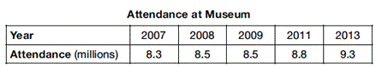
- State the linear regression equation represented by the data table when x = 0 is used to represent the year 2007 and y is used to represent the attendance. Round all values to the nearest hundredth.

- State the correlation coefficient to the nearest hundredth and determine whether the data suggest a strong or weak association

  - Fill in the following table to find the residuals
year
Attendance (millions)
Predicated attendance
Residuals
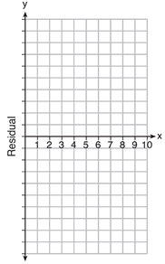
  - Create a residual plot on the axes below, using the residual scores in the table above.

- Based on the residual plot, state whether the equation is a good fit for the data. Justify your answer

- Explain what the y-intercept and slope means in the context of the problem of the equation of line of best fit

Review Questions:
- Which expression is equivalent to 2(3g − 4) − (8g + 3)?
- −2g – 1 3. −2g − 5
- −2g – 7 4. −2g − 11
- What is the solution to the inequality 2 + $\frac{4}{9}$x ≥ 4 + x?
- x ≤ – 3. x ≥ –
- x ≤ 4. x ≥
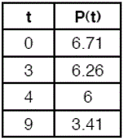
- The table below represents the height of a bird above the ground during flight, with P(t) representing height in feet and t representing time in seconds. The average rate of change from 3 to 9 seconds, in feet per second is .

  - $-0.15$ 3. $-20$
  - $-0.475$ 4. $-2.105$

- Which system of equations has the same solution as the system below?
2x + 2y = 16
3x − y = 4
- 2x + 2y = 16 3. 2x + 2y = 16
6x − 2y = 4 6x − 2y = 8

- x + y = 16 4. 6x − 6y = 48
3x − y = 4 6x + 2y = 8
- A plumber has a set fee for a house call and charges by the hour for repairs. The total cost of her services can be modeled by c(t) = 125t + 95. Which statements about this function are true?
I. A house call fee costs $95.
II. The plumber charges $125 per hour.
III. The number of hours the job takes is represented by t.
- I and II, only
- I and III, only
- II and III, only
- I, II and III
- State whether (7) () is rational or irrational.
- irrational because both factors are irrational
- rational because both factors are rational
- irrational because one factor is irrational
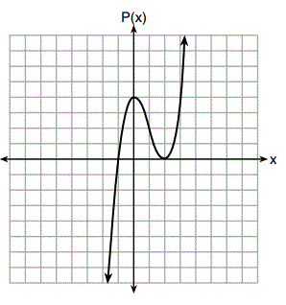
- rational because one factor is rational
- Wenona sketched the polynomial P(x) as shown on the axes below.
Which equation could represent P(x)?
- P(x) = (x + 1)(x − 2)²
- P(x) = (x − 1)(x + 2)²
- P(x) = (x + 1)(x − 2)
- P(x) = (x − 1)(x +2)
- The zeros of the function f(x) = 2x³ + 12x − 10x² are
- {2, 3} 3. {−1, 6}
- {0, 2, 3} 4. {0, −1, 6}
- For a recently released movie, the function y = 119.67(0.61)^{x} models the revenue earned, y, in millions of dollars each week, x, for several weeks after its release. Based on the equation, how much more money, in millions of dollars, was earned in revenue for week 3 than for week 5?
- 37.27 3. 27.16
- 17.06 4. 10.11
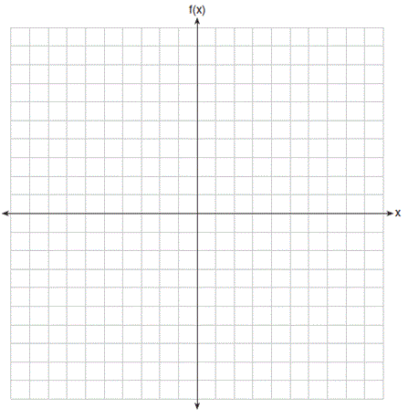
- Graph the following function on the set of axes below.
$$f\left(x\right)=\left\{\begin{aligned}\left|x\right| -3≤x<1 \\ 4 1≤x≤8\end{aligned}\right.$$

